**Assignment-2**

**1. Create some users:**

* **Named “alex” with its home directory at /home/user1 and give password “pass1”.**
* **Named “brew” with its home directory at /mnt/user2 and give password “pass2”.**
* **Named “nora” without its home directory**
* **Named “panny” with custom UID 2112, and assign password “pass-4”**
* **Named 'texas' without using the useradd or adduser commands. *(Hint: Make changes in the 7 user configuration files)**

**Ans:**









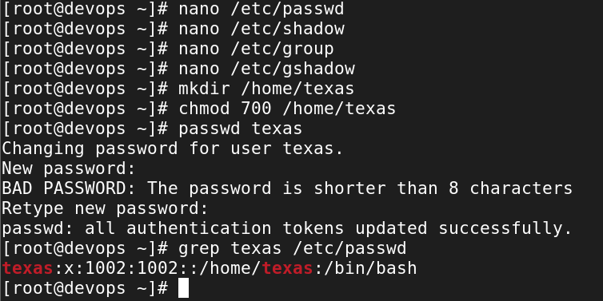

**2. Log in as user alex using the su and su - commands, and explain their differences.**

**Ans:**





**Differences Between su and su -:**

| **Feature** | **su alex** | **su - alex** |
| --- | --- | --- |
| Environment Variables | Retains original user's environment. | Loads alex's environment (e.g., PATH). |
| Working Directory | Stays in the current directory. | Switches to alex's home directory. |
| Login Shell | Does not provide a login shell. | Provides a full login shell. |
| Configuration Files | Does not load .bash_profile, .bashrc, etc. | Loads .bash_profile and .bashrc. |

**3. Set a password policy for all above users with the following requirements:**

* **The maximum password age should be 30 days, and the minimum password age should be 10 days.**
* **Set the password expiry date for all users to December 31, 2025.**

**Ans:**

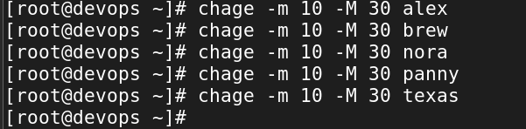

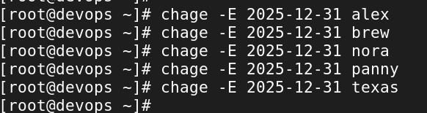

**4. Modify the user "alex":**

* **Add a comment: "I am alex"**
* **Change the UID to 2581**
* **Change the shell to "nologin"**

**Ans:**

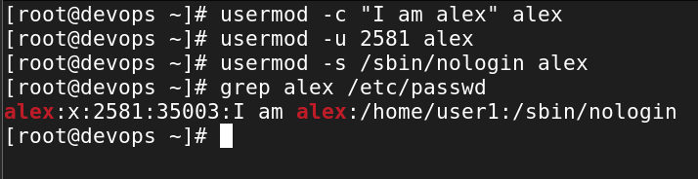

**5. Create group with following configuration:**

* **Named “north” with secondary group member “alex” & “texas”.**
* **Named “south” with GID “2222”.**

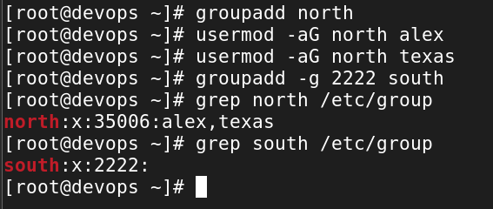

**6. Grant user Alex administrative privileges through the wheel group so that Alex can add Panny to the admin group without requiring root access.**







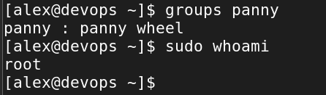

**7. Change the group name from “south” to “dakshin”.**

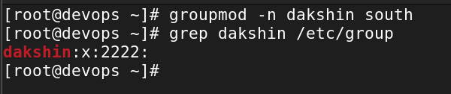

**8. Create a system user named “ping” and check its UID.**

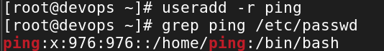

**9. Create a group named goa with GID 11000. Set this group as the supplementary group for “brew”**

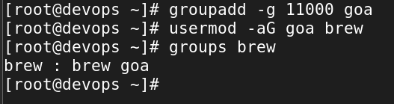

**10. Create a group named “prod”. Then, create two users, user2 and user1, and set both the user’s primary group to prod.**





**11. Change the password policy for the USER3 and USER4 accounts to expire on 2026-01-15.**

**Ans:-**



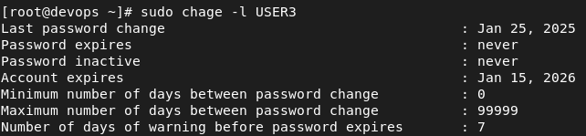

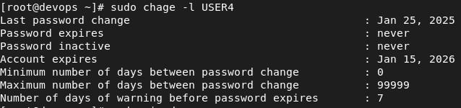

**12. Configure administrative rights for all members of the Goa group to execute any command as any user.**

**Ans:-**



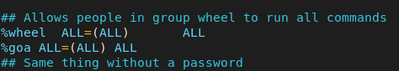

**13. How would you check all failed login attempts on the system from the last 10 days? Write the command and display the output.**

**Ans:-**



**14. How would you determine how many users are currently logged into the system? Write the command to achieve this.**

**Ans:-**

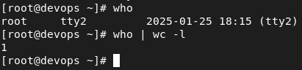

**15. Add the user "sara" to the "wheel" group and create a collaborative directory /collaborative/infodir.**

**Ans:-**



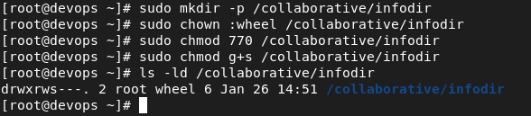

**16. Configure login/logout messages:**

* **When you log in with a new user, display a message: "Hello, you are logged in as USER" (where USER is replaced with the logged-in username).**

**Ans:-**



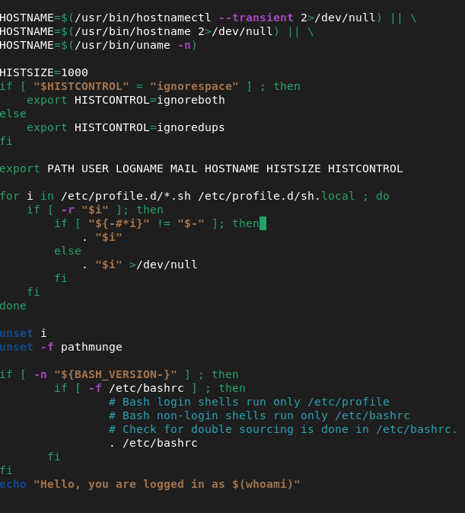



* **When you log out, display: "You are logged out now".**

**Ans:-**





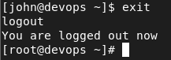

**17. Configure system parameters for newly created users:**

* **Warning period for password expiry: 5 days**
* **Minimum user UID: 2000**
* **Maximum user UID: 70000**

**Ans:-**



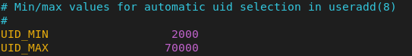

**18. Create a directory /data and configure the system so that all newly created users get /data as their home directory by default.**

**Ans:-**

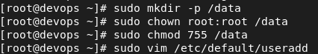

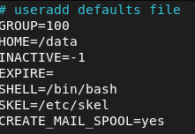

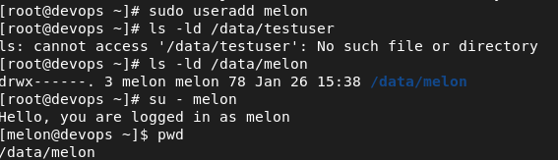

**19. Name a file where we can set a file size limit upto 200 MB for a single file.**

**Ans:- File -> /etc/security/limits.conf**



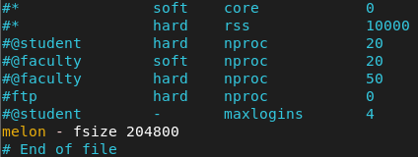

**20. Check the last three users who logged into your system.**

**Ans:-**

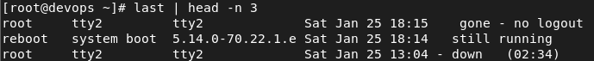

**21. As a system administrator, how would you configure the system to ensure that:**

* **Automatically create an instructions.txt file in the home directory of every new user upon account creation.**

**Ans:-**



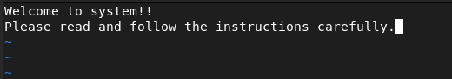

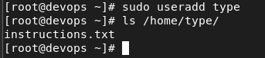

* **Ensure that the mail directory for every newly created user is set to /home/spool/mail/ by default?"**

**Ans:-**



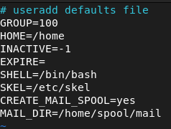

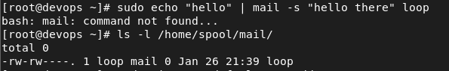

**22. Delete some users**

* **Named ‘alex’ and ‘brew’ with its all data contents including mail data.**

**Ans:-**



